**KHUSHBU DILIPKUMAR JOSHI**

**FY6259**

**004520648**

**Signalj-chat-scala Template**

Without modification the screen captures:

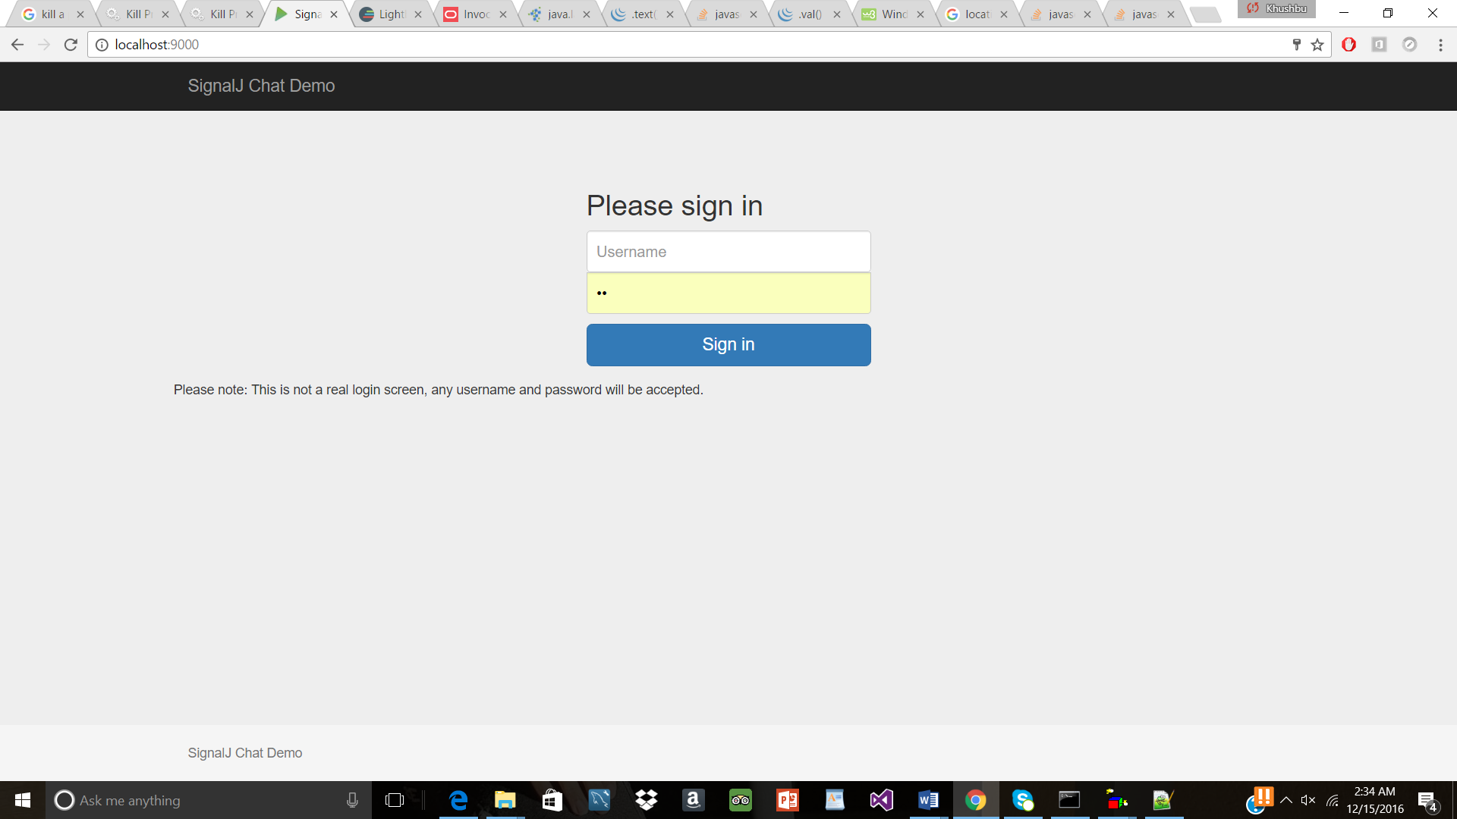

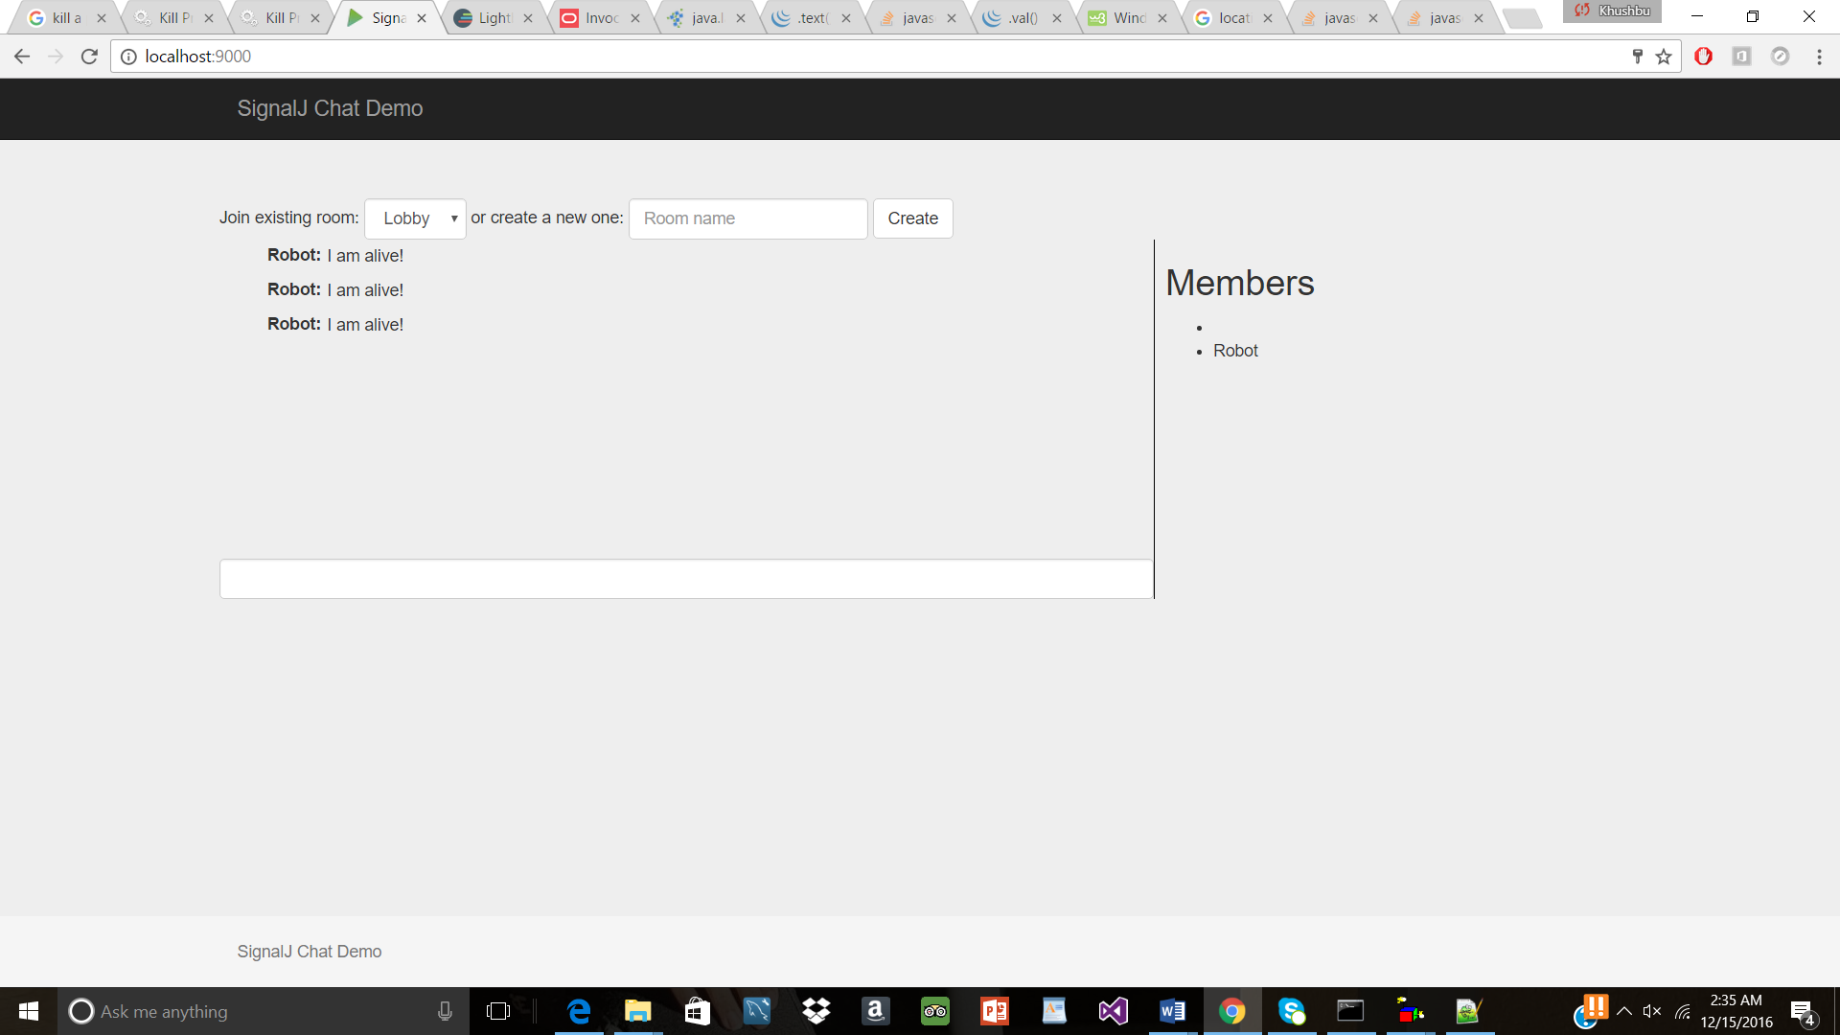

**CSS Modifications:**

**Change-1** Changing the background of the entire body to moder-bg.jpg

**Change-2** Adding css properties to talk element by setting position, border, color, font-style, font-family, background-position, background-repeat, etc properties – for the textarea where we can type talk text

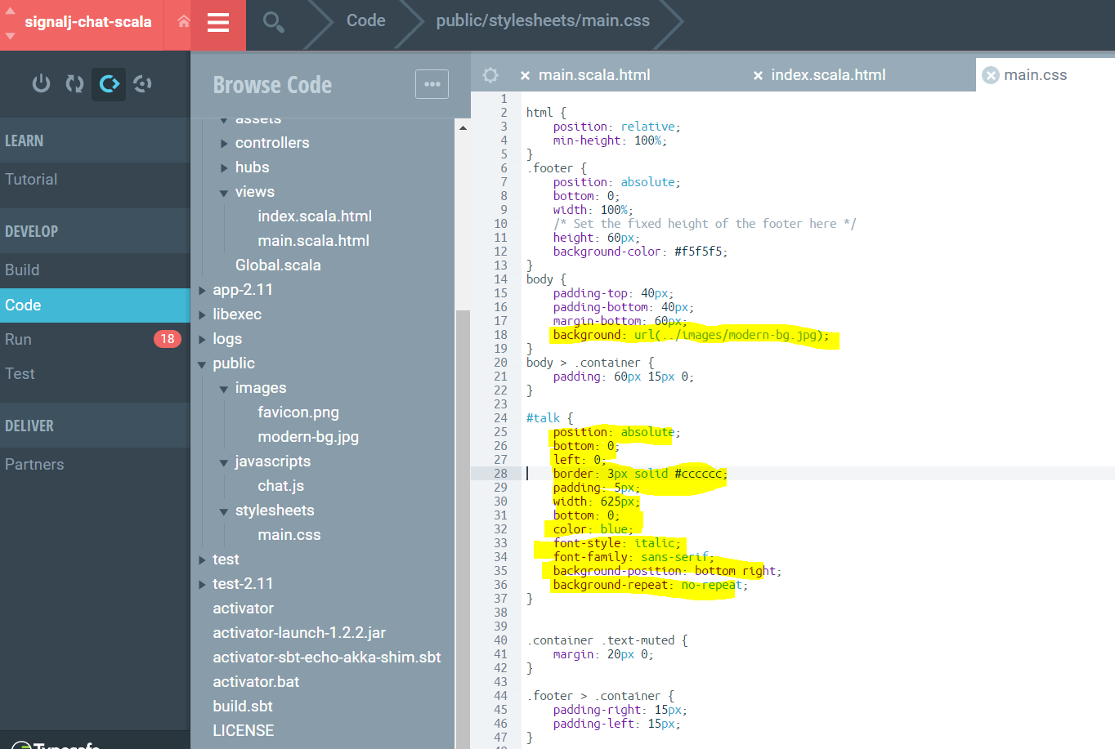

**Screen capture after css changes:**

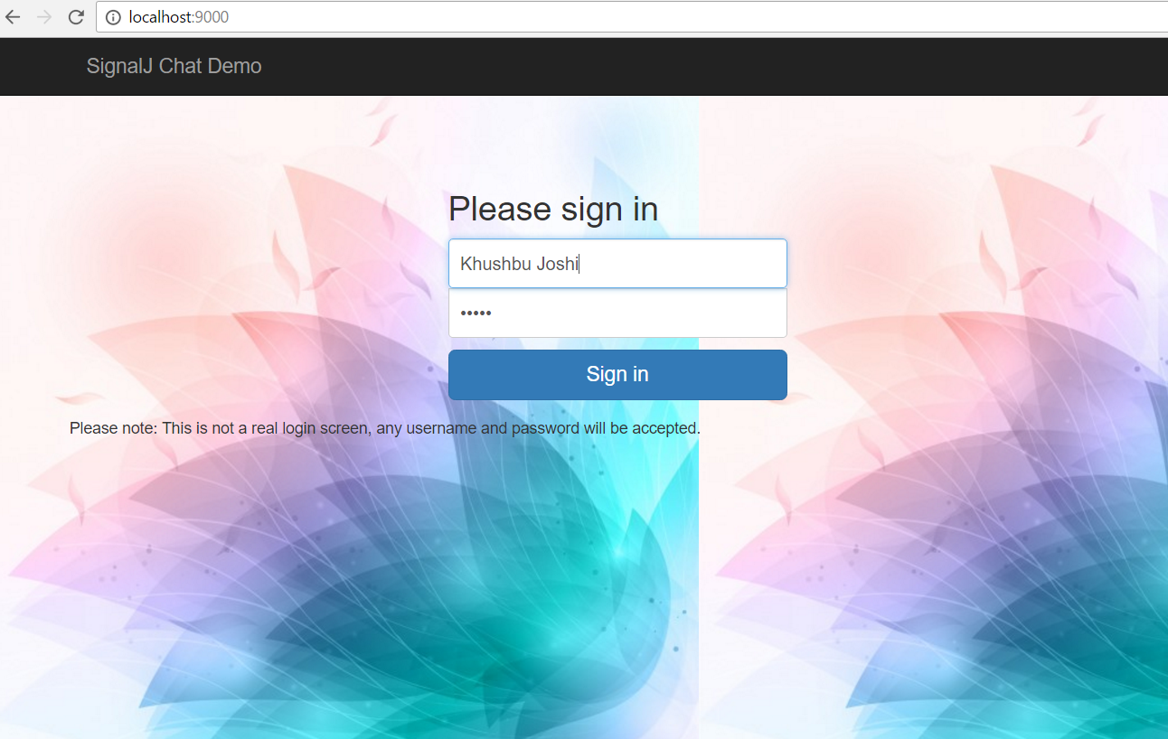

After making changes in the talk text area

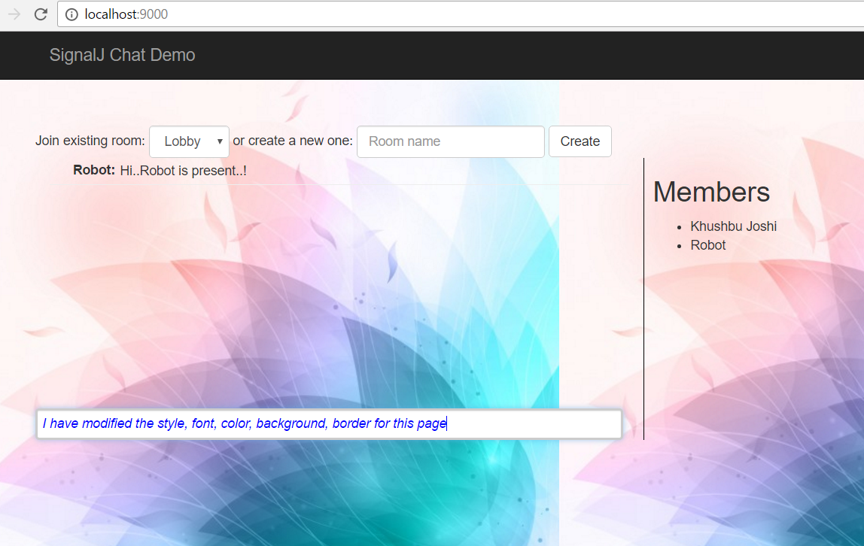

**Modifications in Javascript**:

In the original template in the first page if username/password or wither of the fields are left blank and ‘login is clicked’ then it will login in

Adding alert if username/password or wither of them or both are blank. Here, only if both are not blacnk then only user is allowed to login.

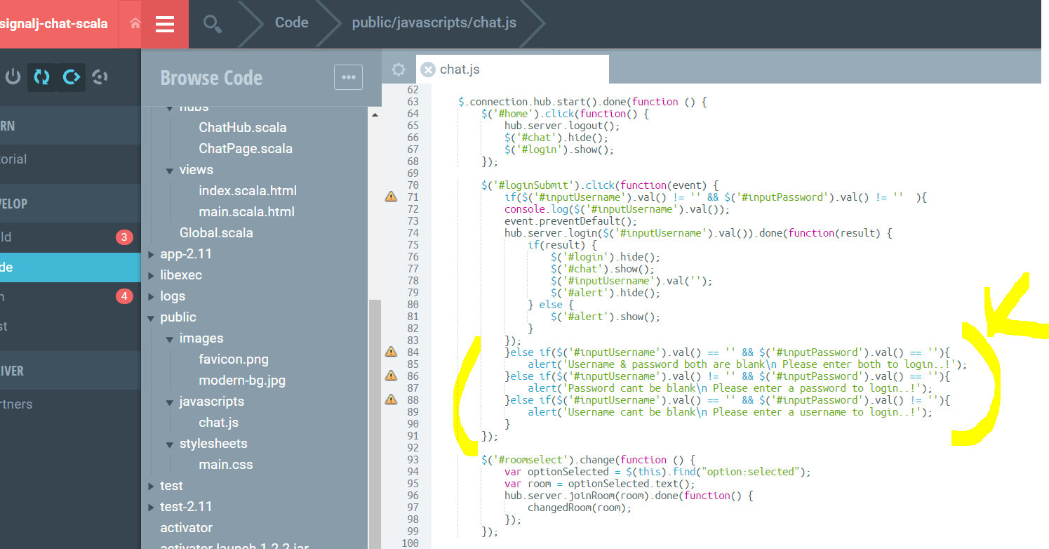

*When Username & Password both the fields are left blank and clicked on ‘Sign In’ button*

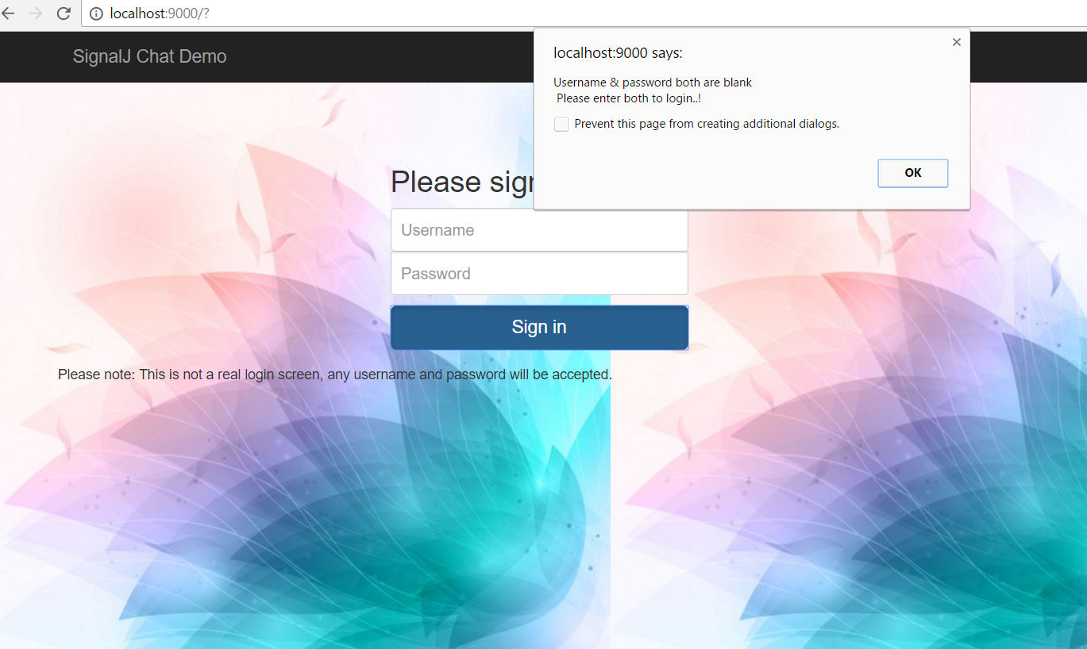

*When only Password field is left blank but username contains some value & clicked on ‘Sign In’ button*

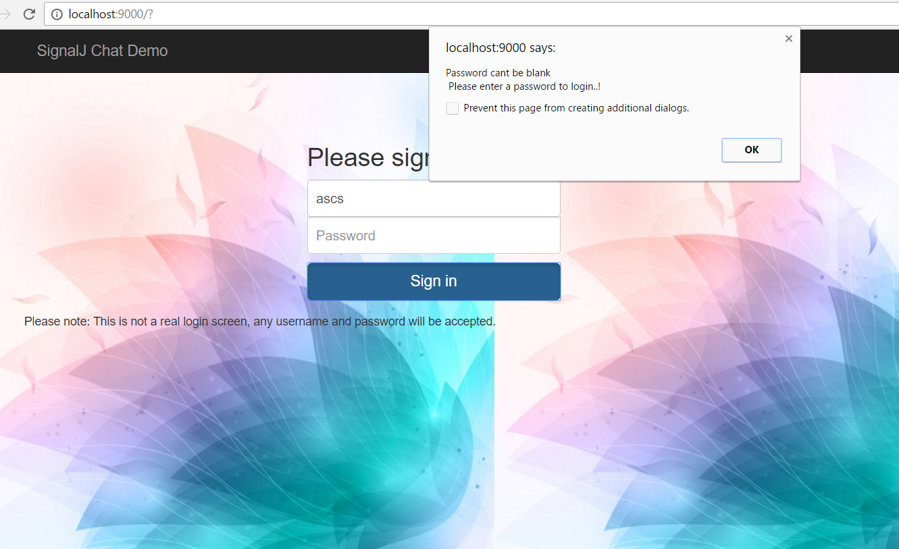

*When only the Username field is left blank but Password contains some value, clicked on ‘Sign In’ button*

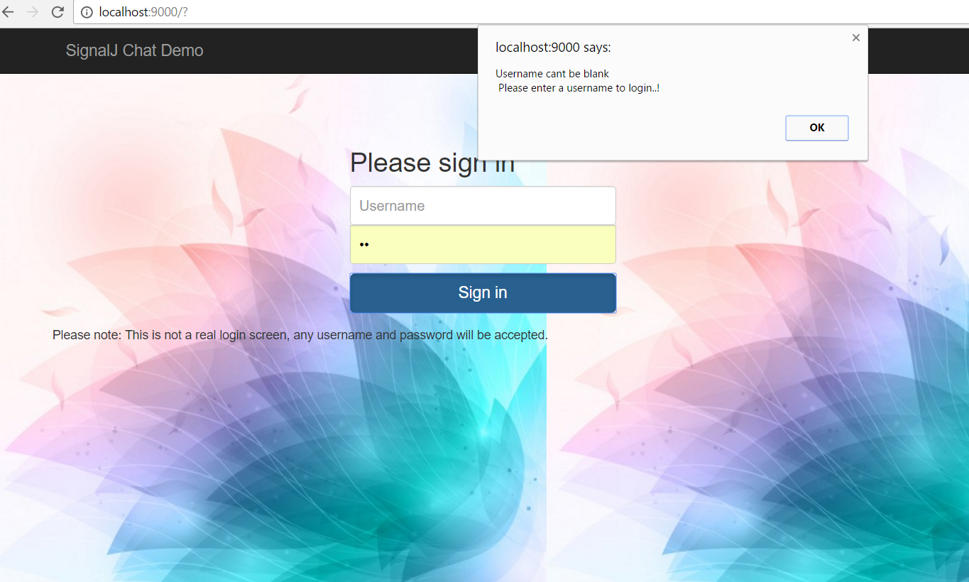

**Scala Modifications**

Screen Capture without modifications



Modifying the message of Robot in Scala

**Change-1** Scala Code changes in Robot.scala

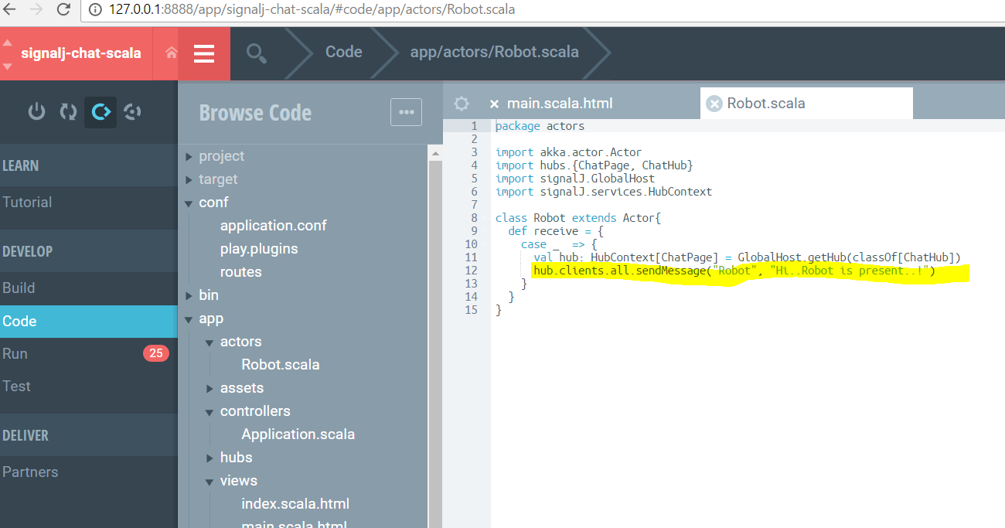

After making modification in the scala code

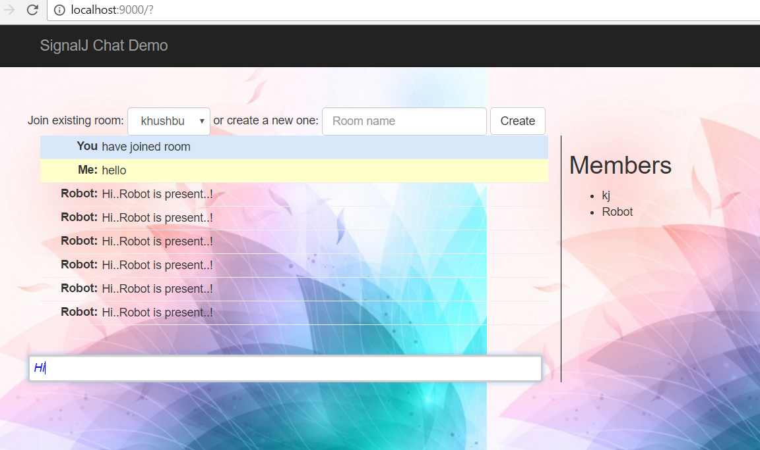

**Change-2** Adding an extra check so that the blank user can’t be added to the room

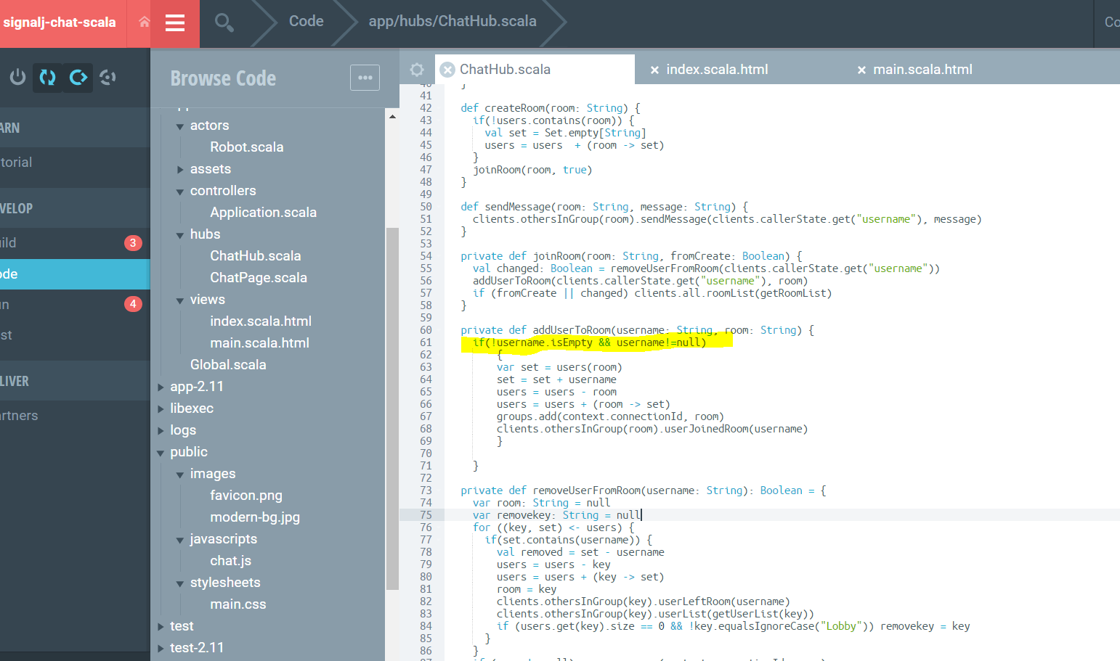

**Template- Reactive stocks**

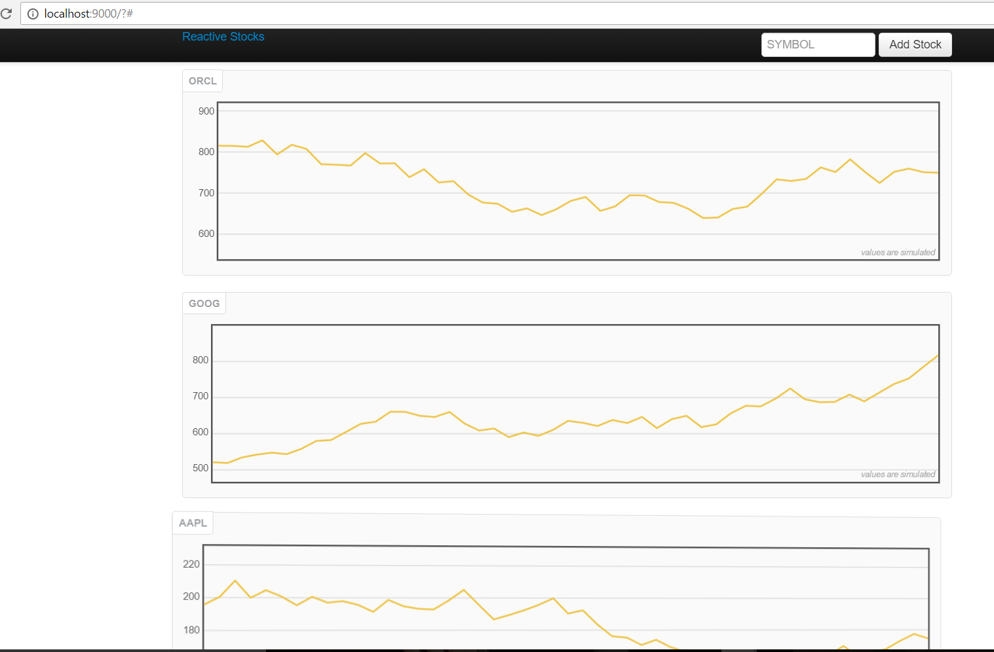

**Scala Changes - Change-1** Changing the scale of the graph i.e. generating the random numbers such that they come in range from any floating point to 100 or more.

**Change 2** Changing the code to fetch the data every 20 milliseconds, so now graph will move quickly or fast in terms of showing the change in dataset.

**Change 3** Changing the code so that for StockHistory the price is dropped by 2

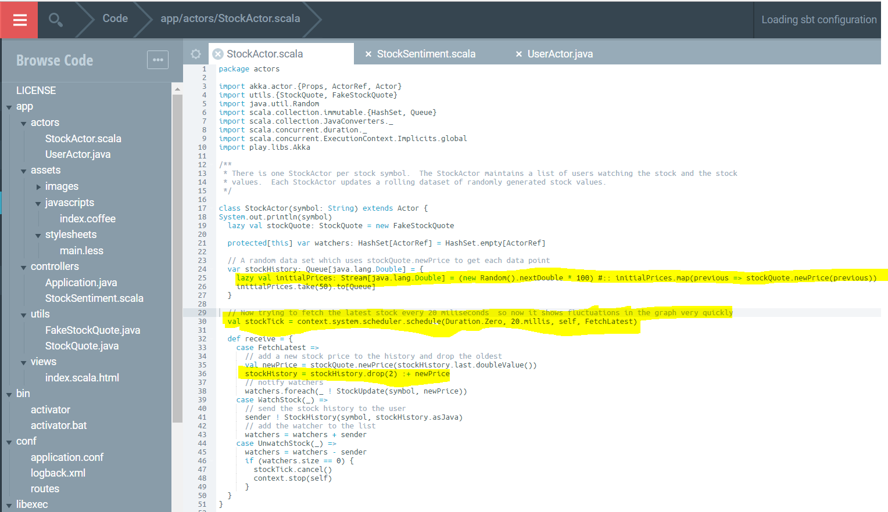

After making change in Scala the graph moves quickly and the range i.e. X-axis also changes

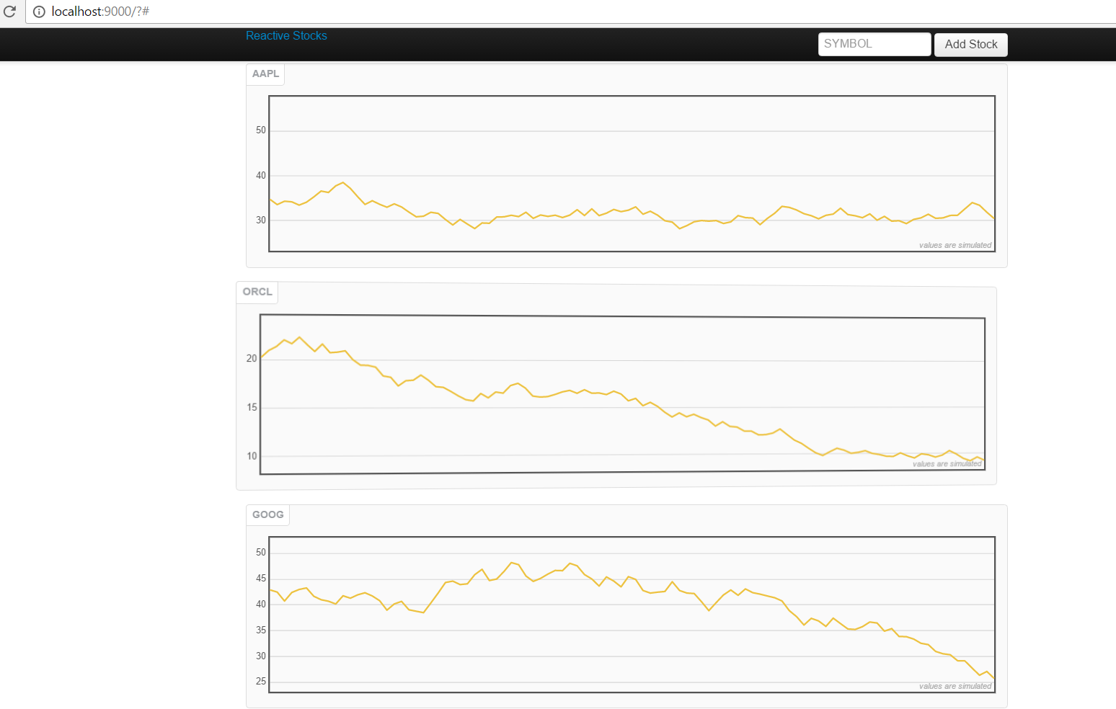

Over the time if you run then data would be like follows

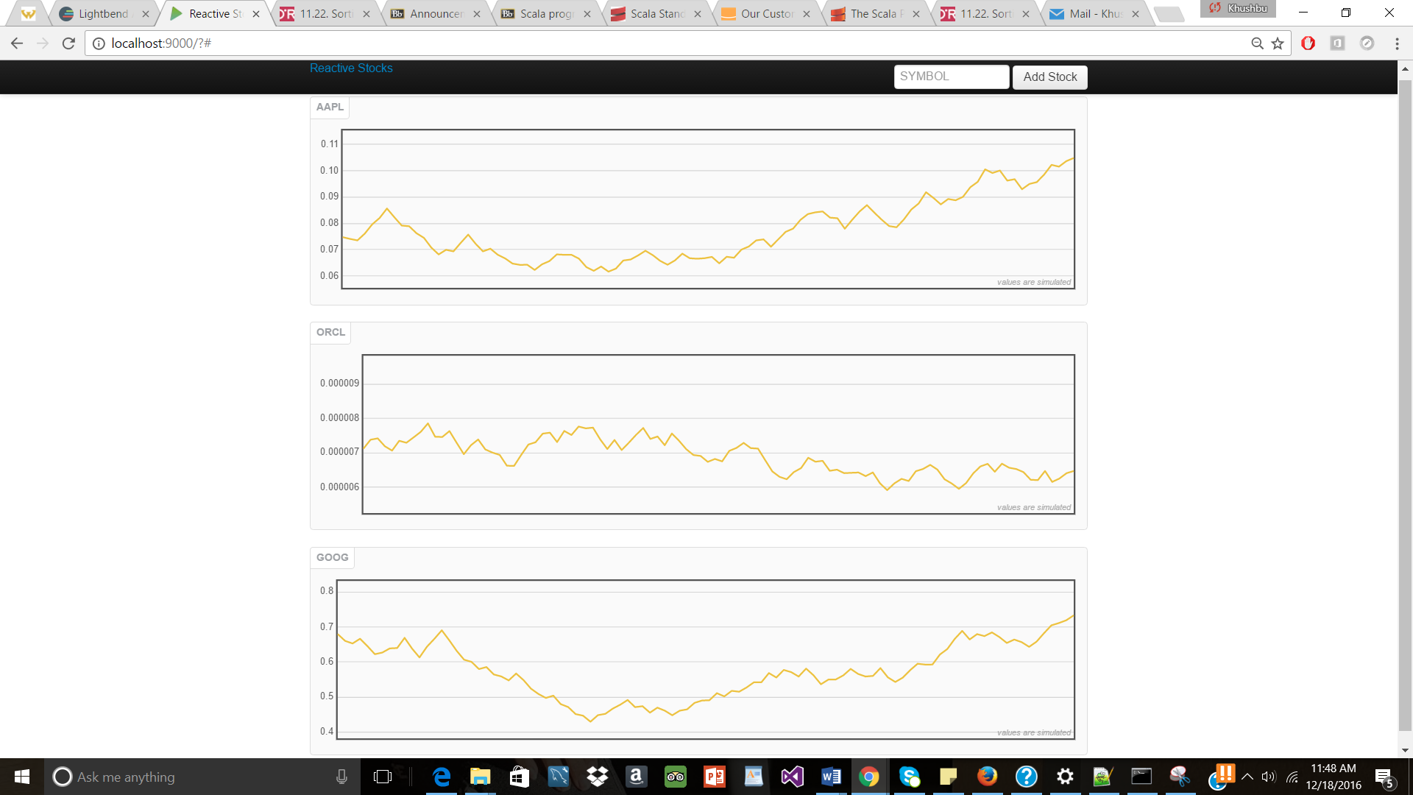

**Change -2**- CSS changes in **main.less file** changing the background of body to give it an image as background

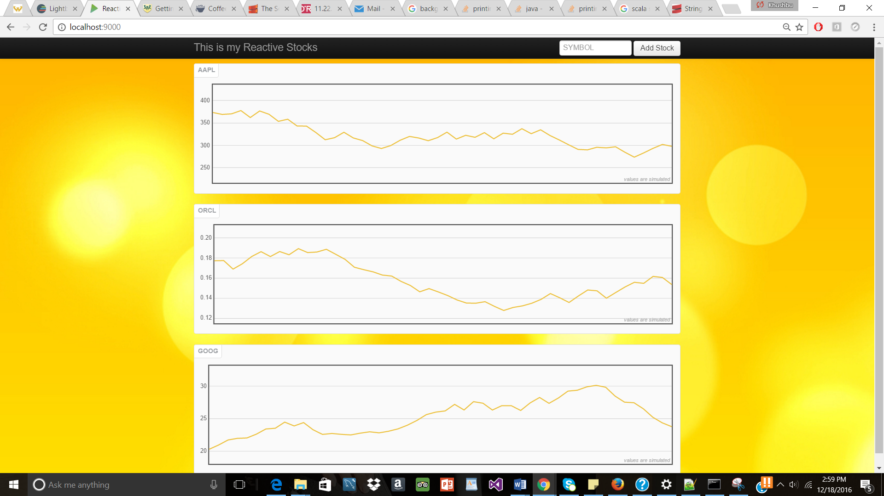

**Change-3** When clicked on any of the graph’s it will flip the graph upside down and for that added webkit-keyframes spinX to make sure it flips upside down for 2 seconds and then regains its position back to normal after 2 secs.

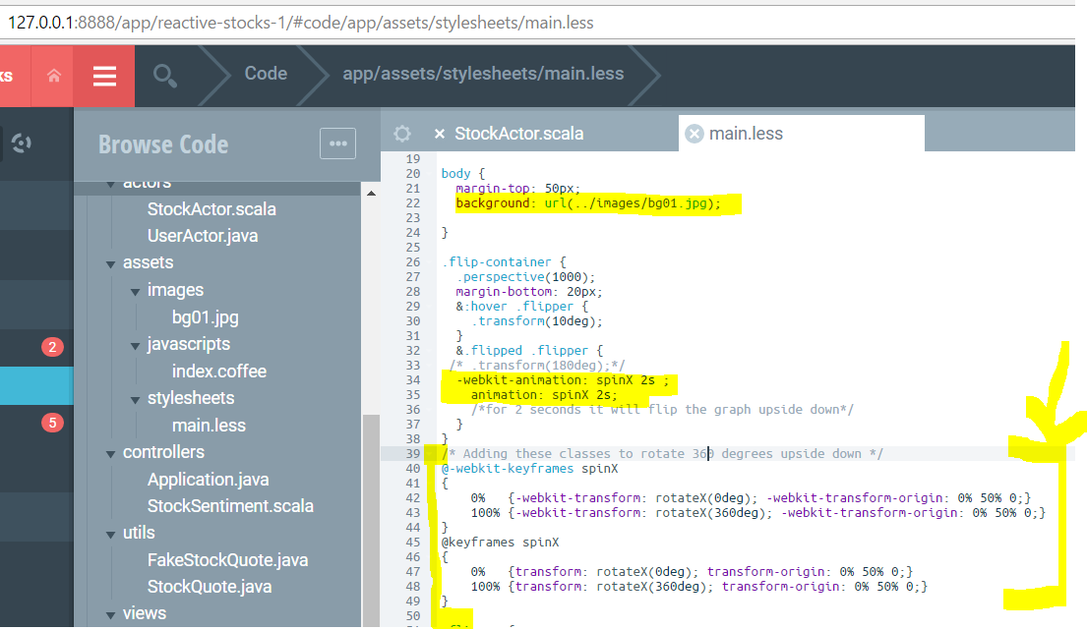

Animation for 2 seconds of flipping upside-down when clicked or double clicked on the graph

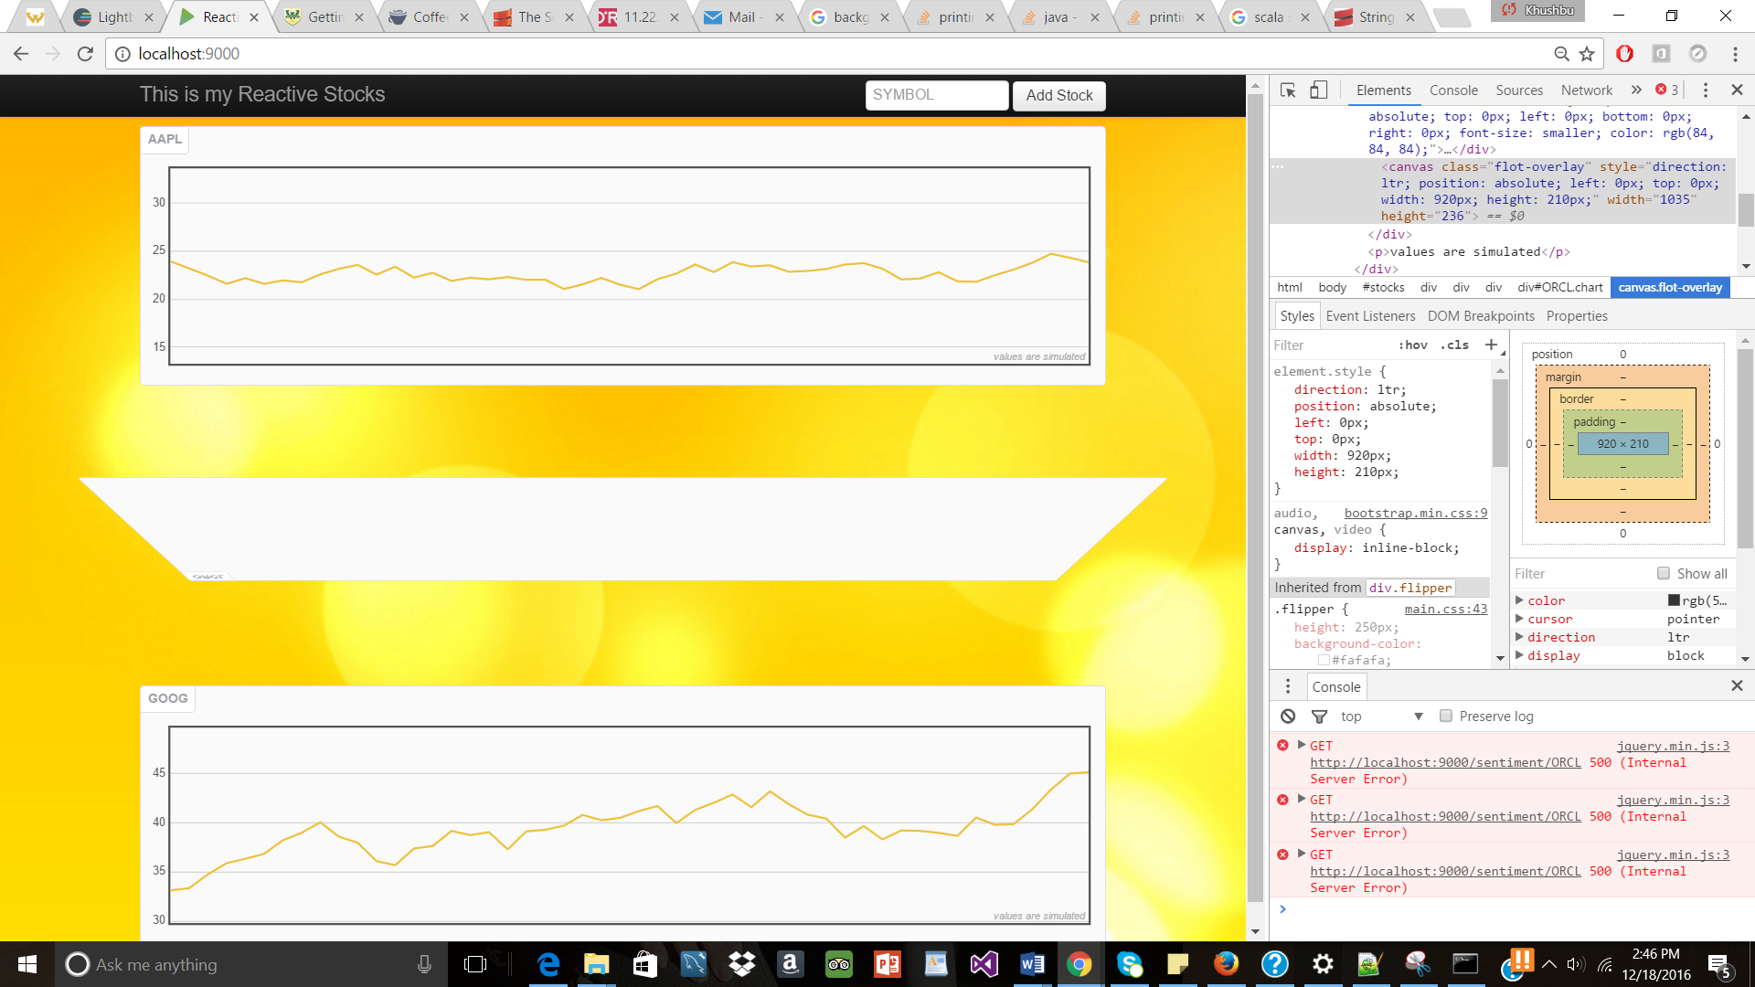

Then making sure the graph is in-proper place after flipping

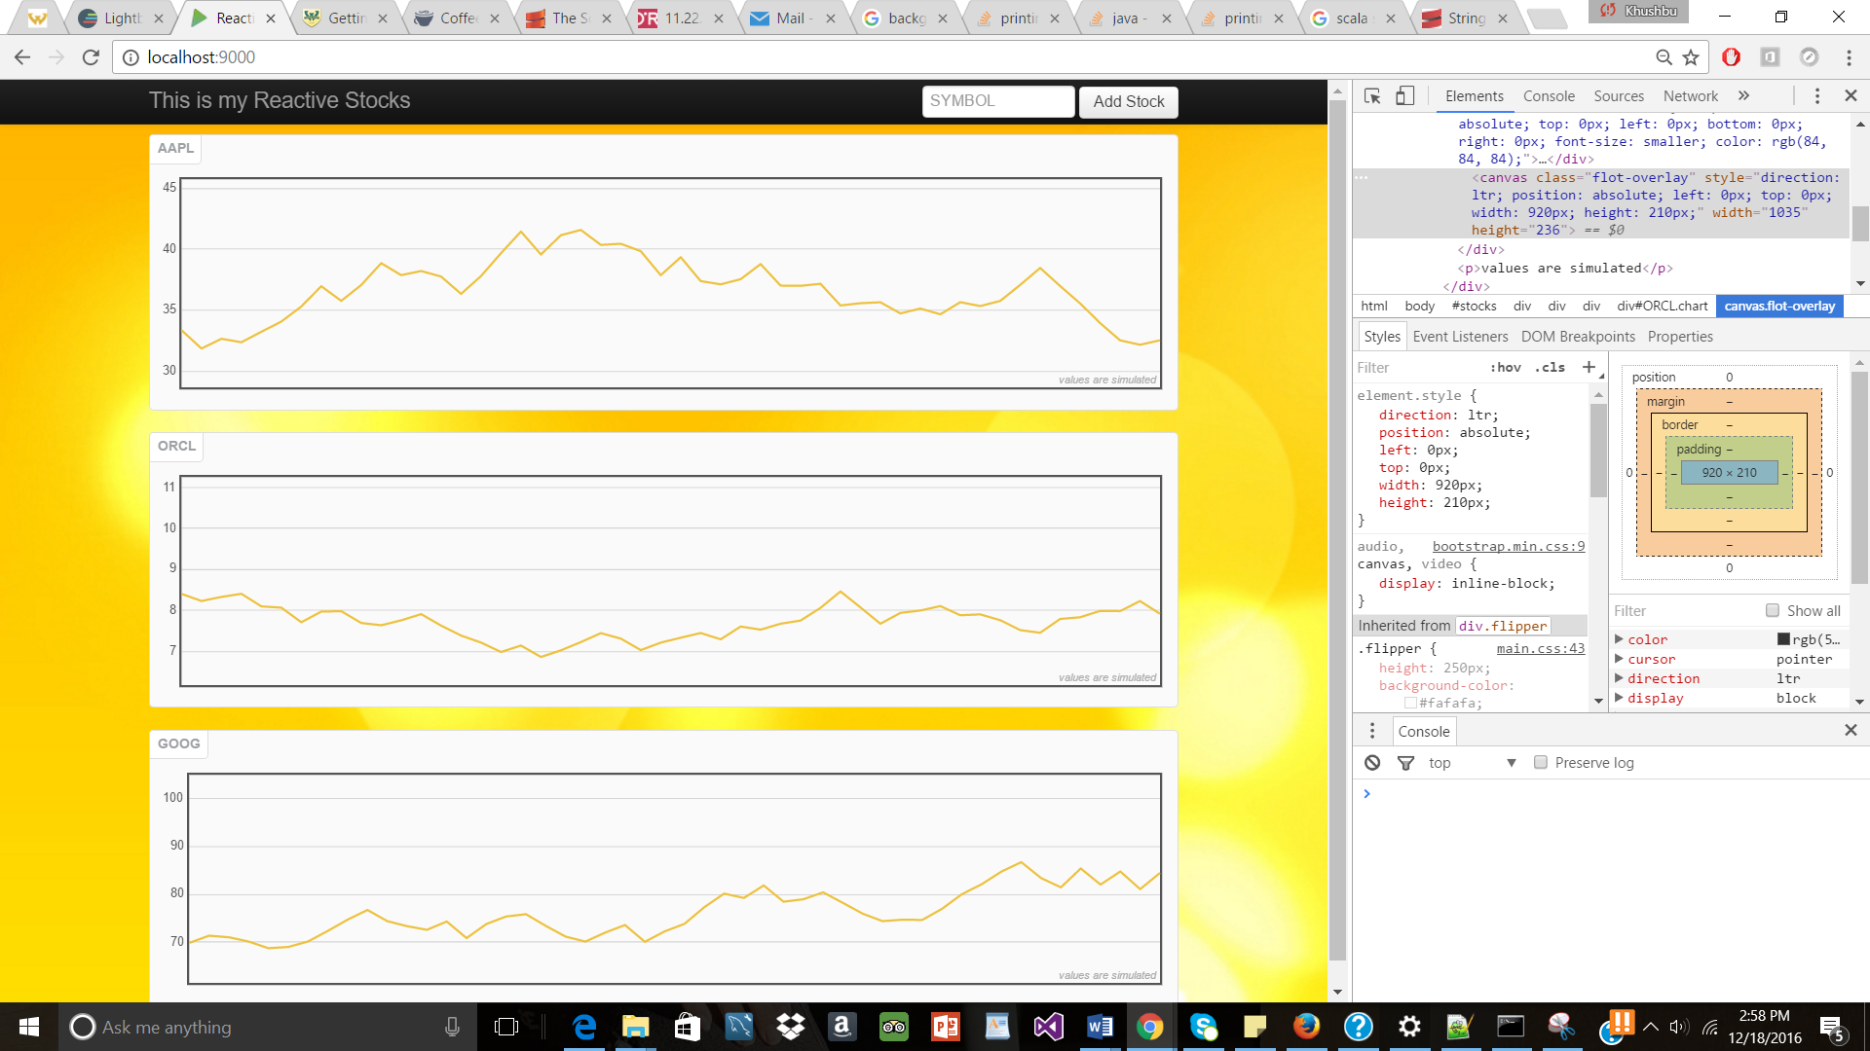

**Coffee Script change**

Made change in coffee script so that now when any blank symbol graph is created then it won’t go forward, so a blank symbol check was made in the submit event and if the input is blank then it would give an alert that symbol.

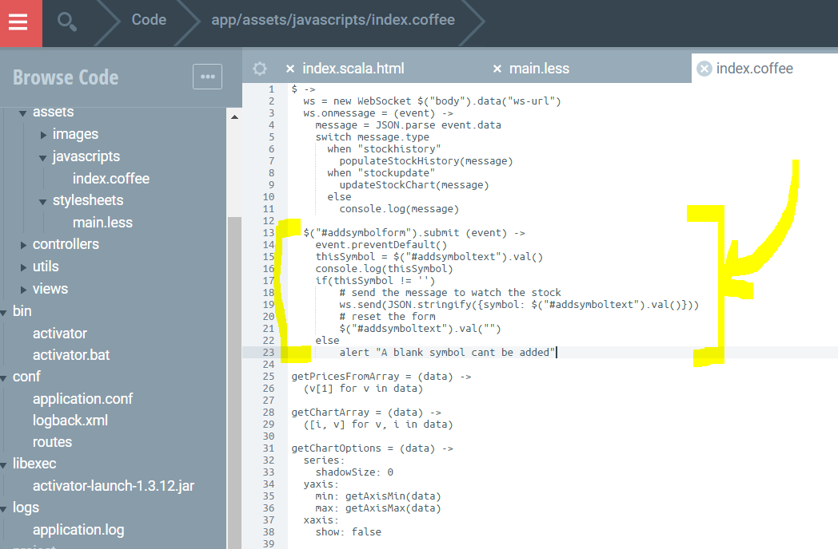

After entering blank symbol and trying to add it, it will give an alert that blank symbol can’t be added

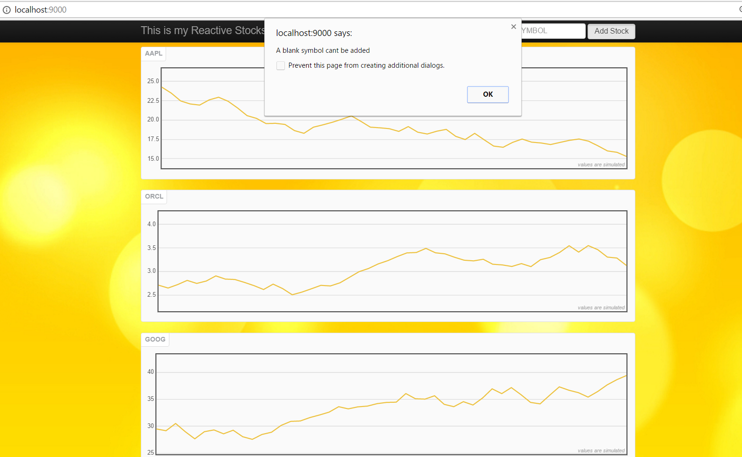

**Tweetmap-workshop Template**

Without modification UI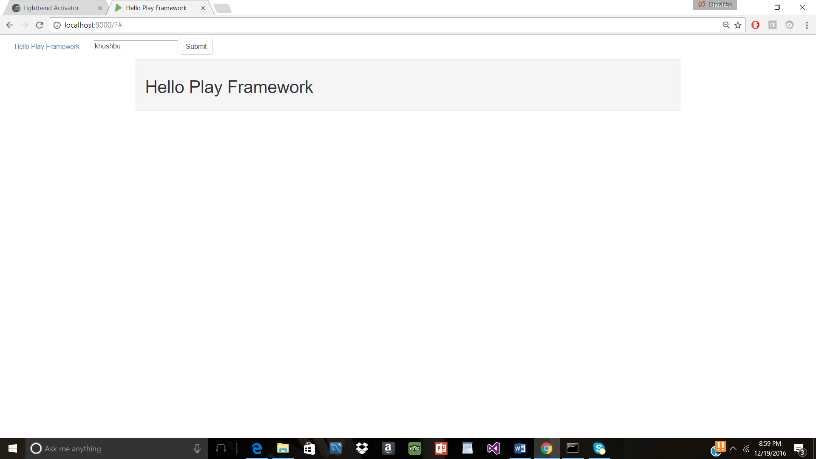

**Changes in Scala**

Change-1 Changing the content of the landing page and also adding a new action with a different content

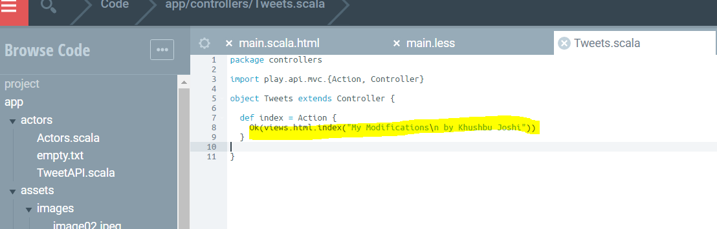

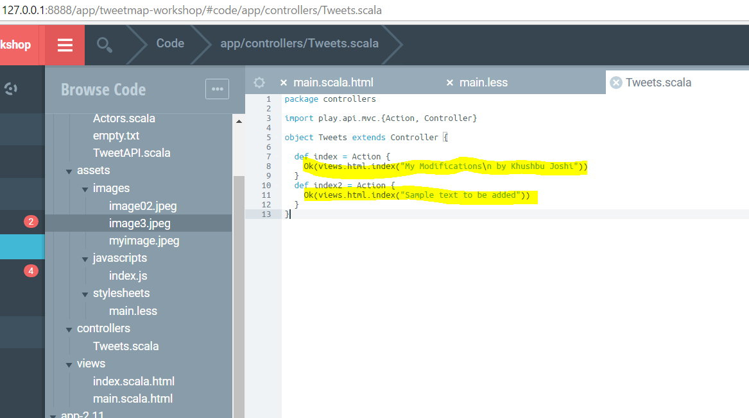

**Change-2** Again adding the content for home with the include for the content assigned

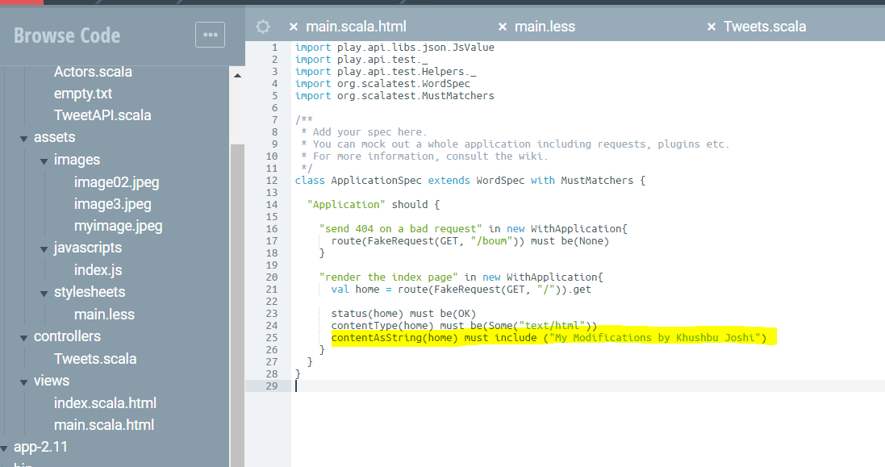

**CSS- LESS changes :**

In the main.less file adding different css styles to change background, font size, weight, color, etc

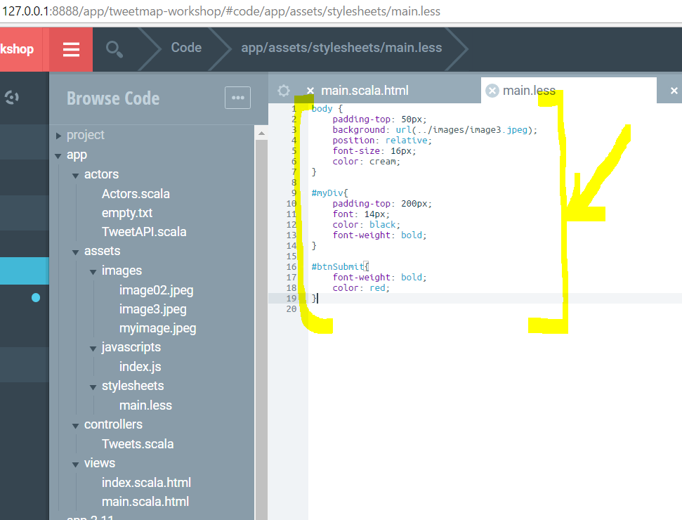

Adding a new div

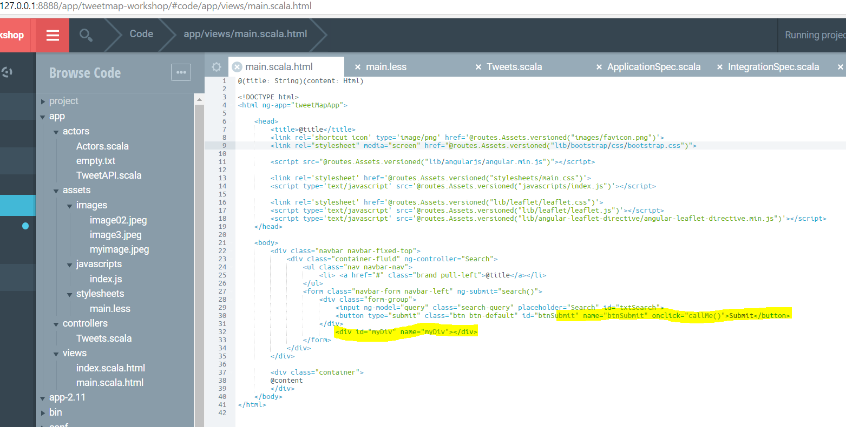

**After Css-LESS changes following is the UI**

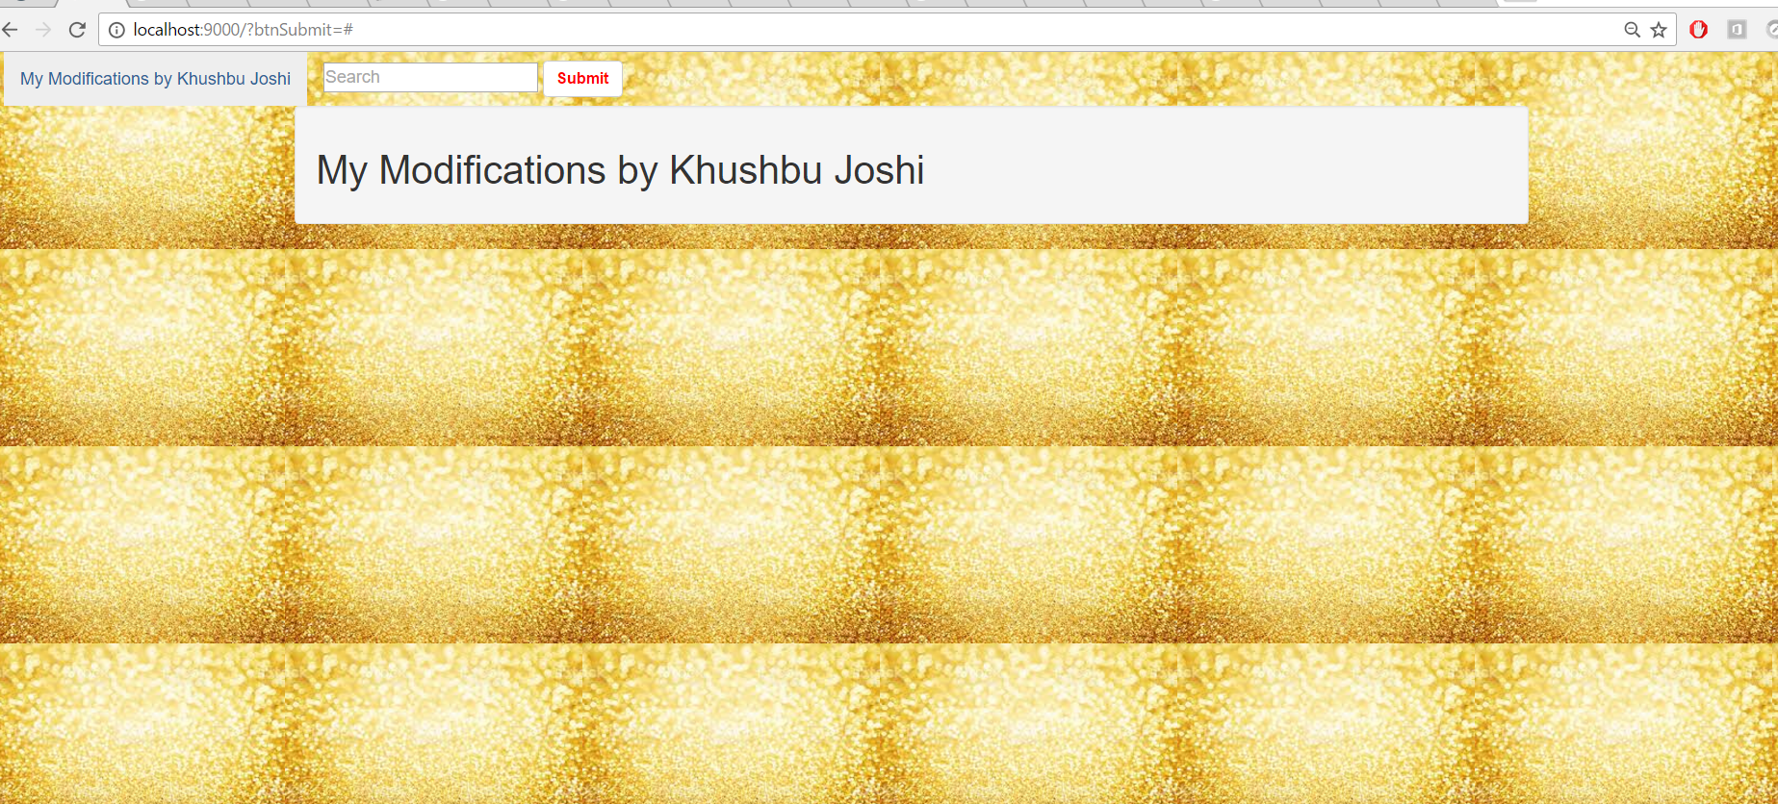

**Javascript changes**

On the click of the button, the **callMe function** will be called and it does the following in javascript

* Changes made to check the Null check for the searched text
* Length check: so if field is left blank and searched it won’t show div i.e. show message
* Trimming to remove the extra spaces from front and the back of the input searched text
* After trimming if length is greater than 0 then display div

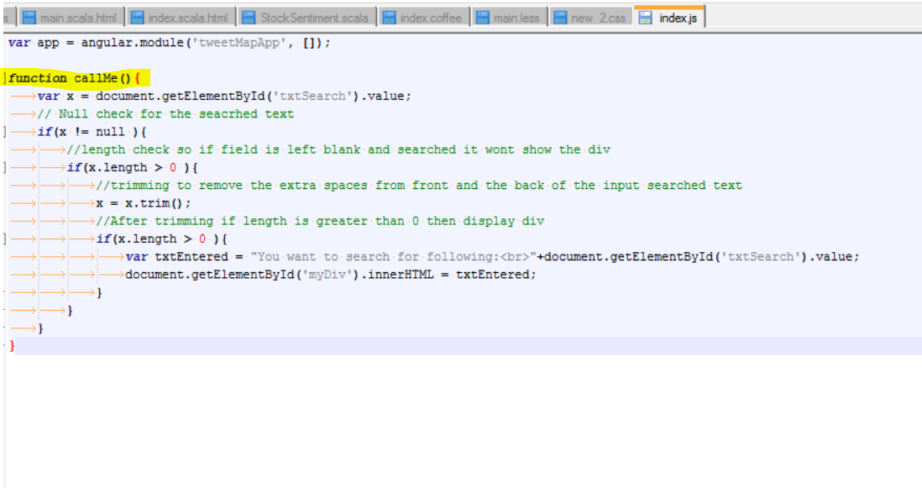

**After Modifications:**

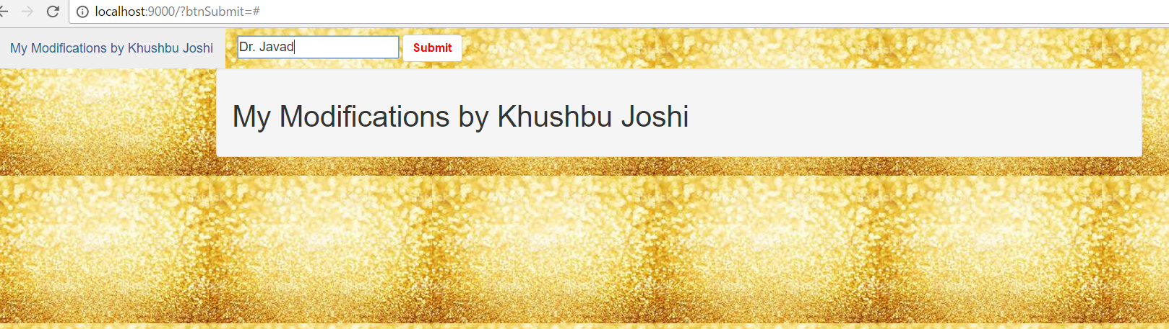

After entering the search text then clicking on Submit, div will be visible with the searched text

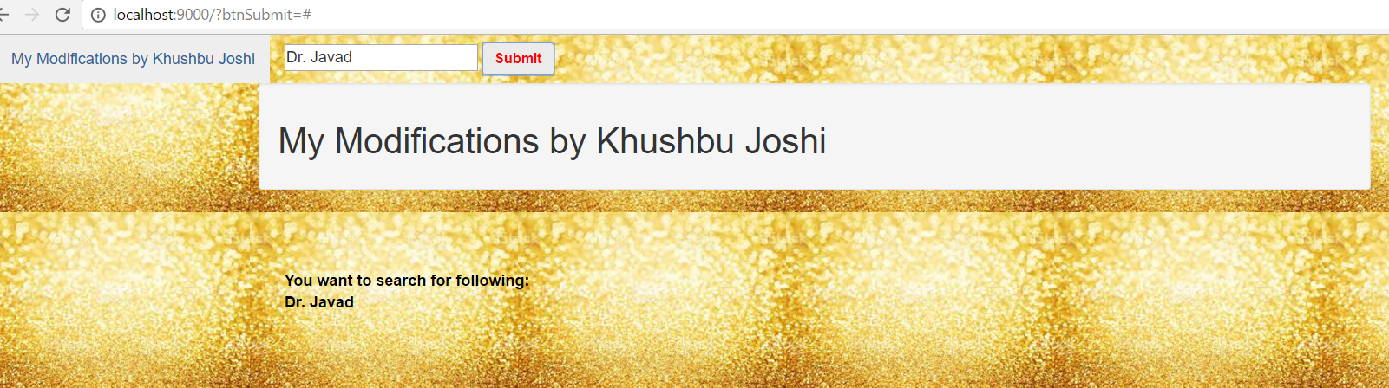

**PROJECT**

**Using the play-scala seed as the basic to build onto the project**

Original template without any modification

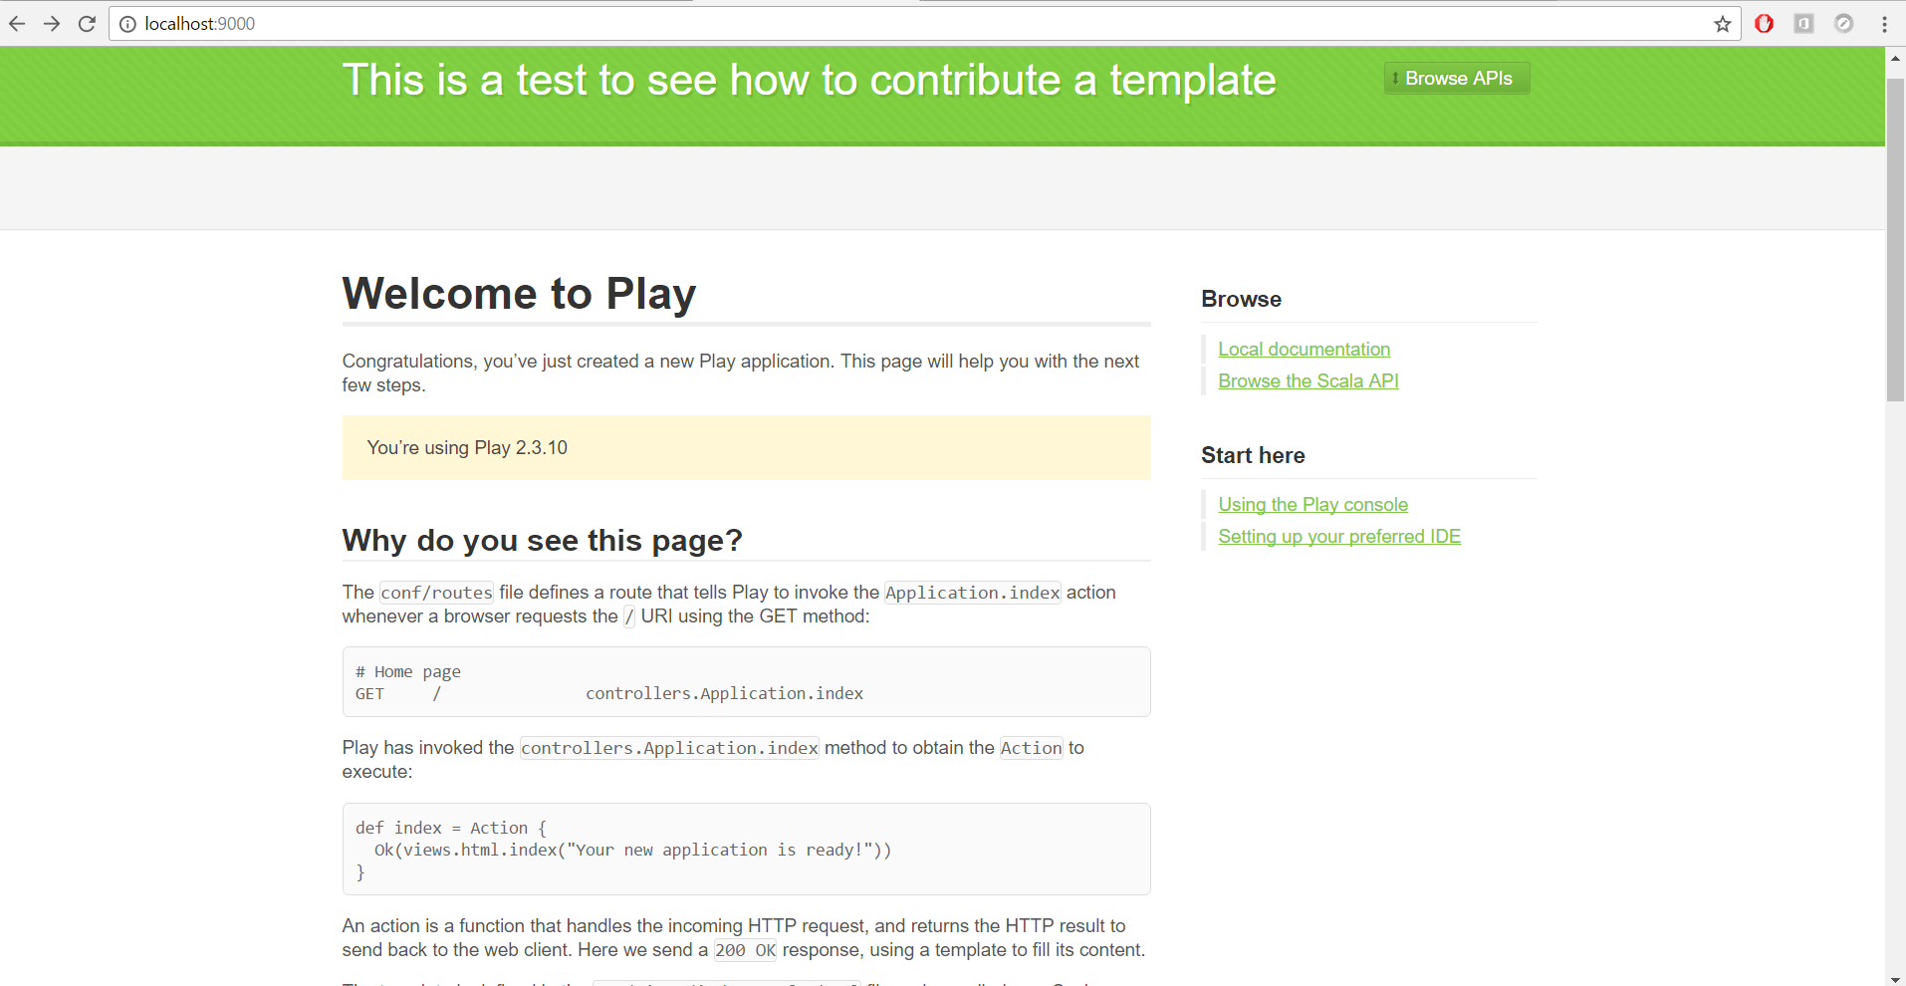

Transforming it into a student’s feedback evaluation form:

Project that will store the feedback of the Student’s for a particular professor for the course Course.

**Sole Purpose of the project:**

* The project this enables a user which is a student to fill the evaluation form for a course.
* When a student missed entering some values and clicking on submit button then he/she is prompted with the use of javascript-coffeescript
* When all form fields are filled up then in the back end through use of actor feedback form gets submitted successfully and data is stored into the database in the back-end.
* When submitted button is clicked user is taken to a new page where all the evaluation form from the database are displayed properly.

The database is enabled to store the feedback of a student and for that a feedback table is created

The feedback table contains following fields:

|  |  |
| --- | --- |
| **Column name** | **Use** |
| **fid** | To uniquely identify a feedback of a student **– Primary key** |
| **sid** | To store student’s access id |
| **studentFnm** | TO store student’s first name |
| **studntLnm** | To store the student’s last name |
| **courseName** | To store name od the course for which evaluation is filled up |
| **rateContent** | Rating whether  Course content was aligned with syllabus from 1-5 - 1 being the least 5 being the highest |
| **ratePace** | Rate the Course pace and level of difficulty was adequate |
| **rateHWK** | Rate whether Homework/Exams/Quizzes were reasonable |
| **rateInfo** | Rate whether  Homework/Exams/Quizzes contained information covered in the course |
| **rateFairness** | Rate Fairness with the students |
| **rateRecommend** | Rate whether student would recommend this course to other students |

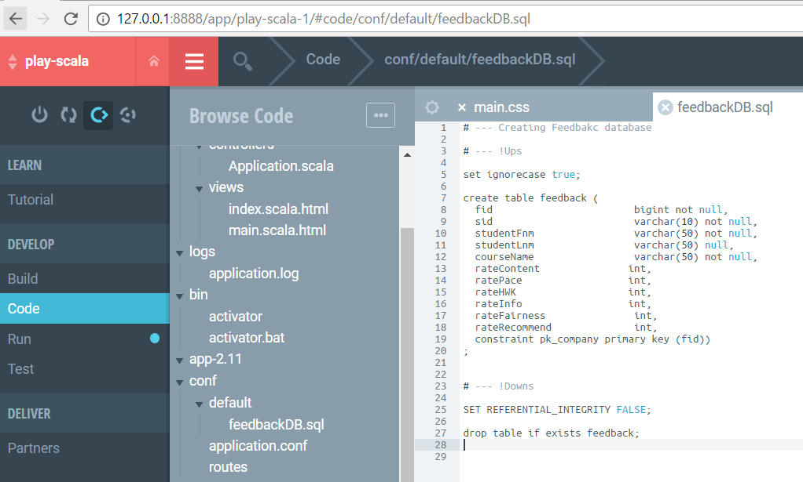

Above is the sql file added to the project to create feedback table

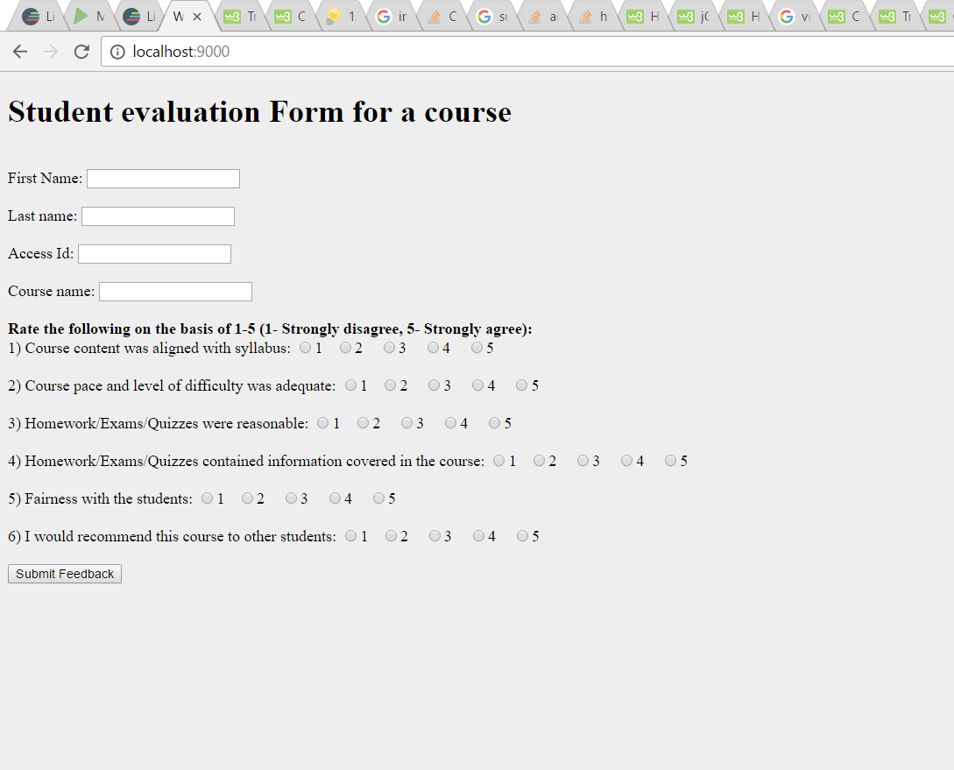

After entering values into the form, so for this in scala made feedback actor with all the fields corresponding to the table data and with the code went on adding the new feedback through scala into the map and ultimately storing it into the database using insert query

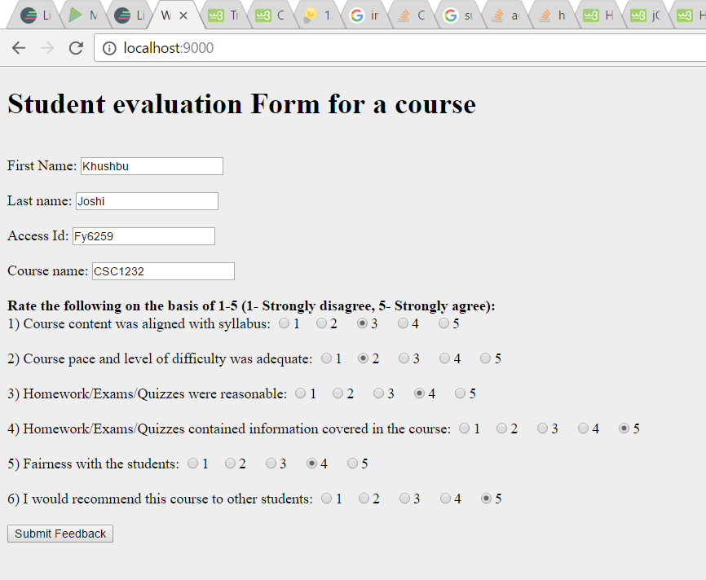

And clicking on submit feedback, we get as follows:

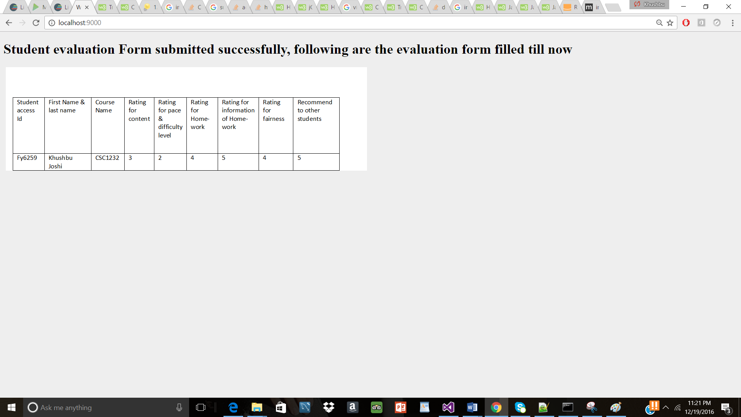

After adding few more evaluation and then submitting the table values will get populated with the data as follows:

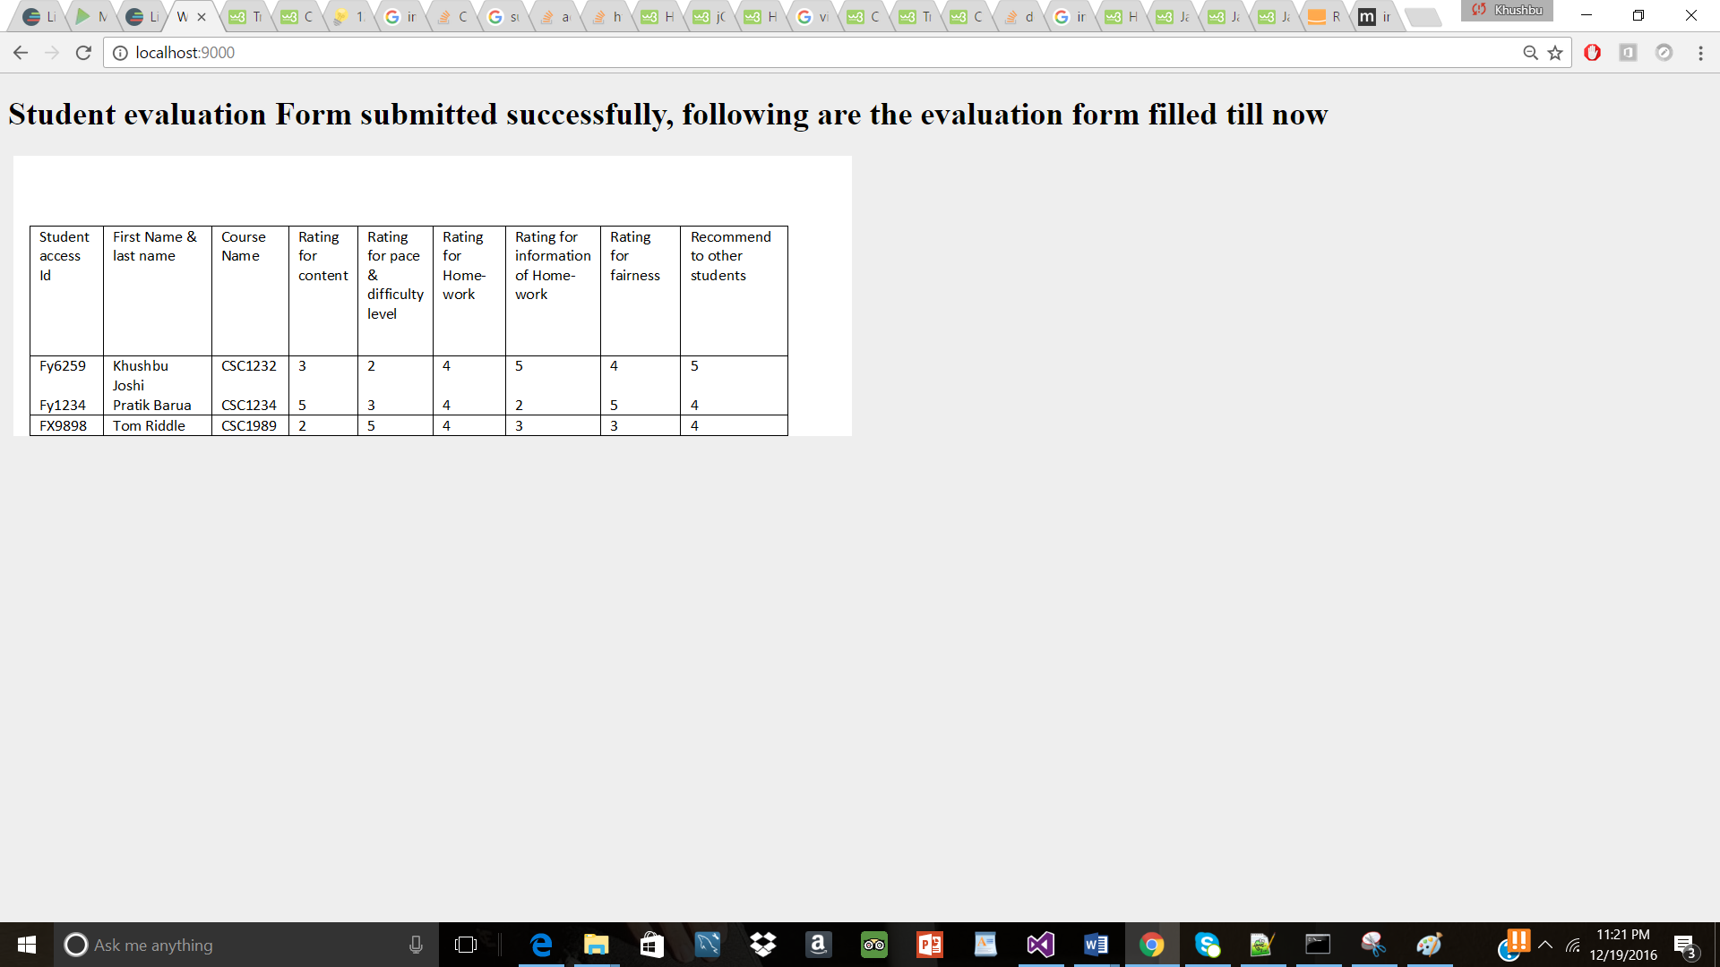

**Javascript and coffee script validation:** All the form fields are required fields so made sure all the fields are filled up for the page to submit if any/all of the required fields are missing alert is displayed, following alert pop’s up when a form with no filled in fields is submitted

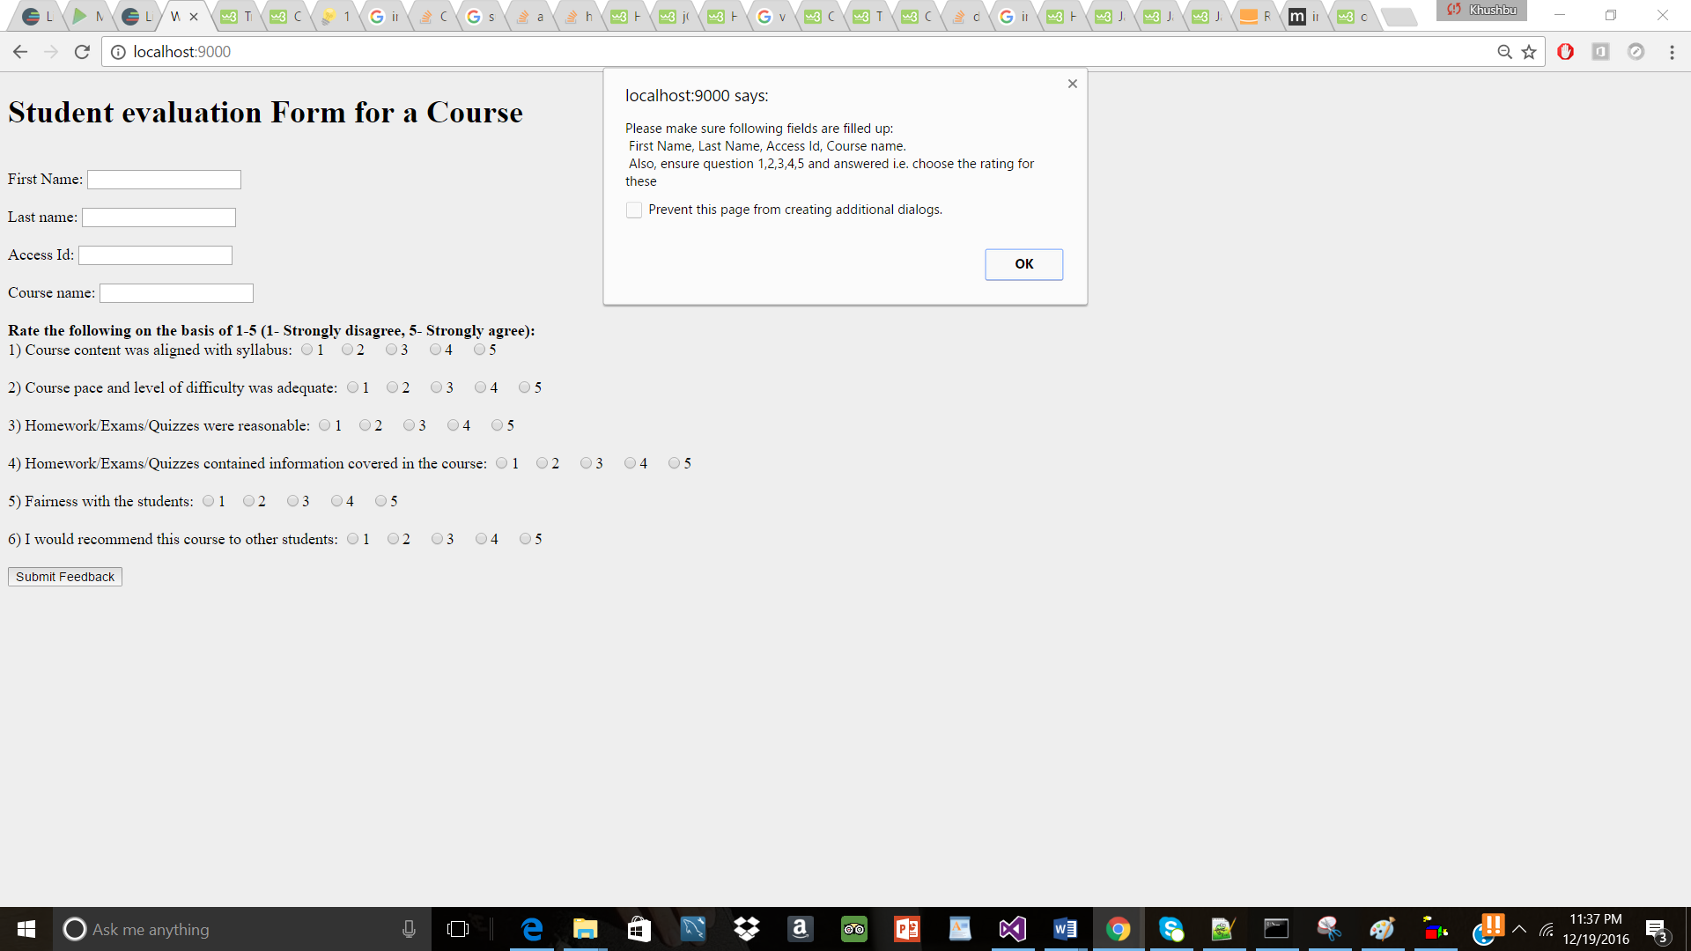

If some fields are left blank following and some of them are filled the message will be displayed accordingly:

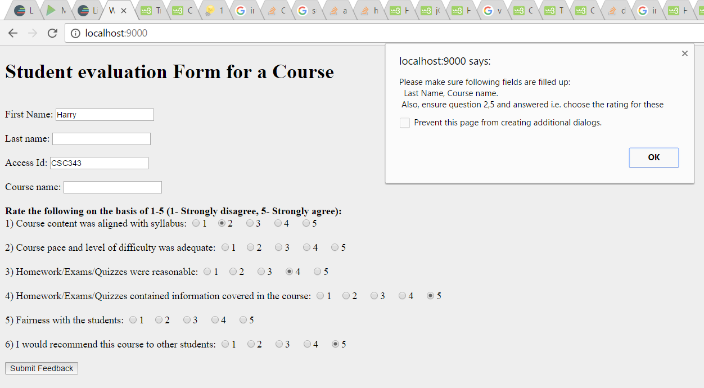

**For CSS:**

Used the bootstrap css to make sure the CSS is attached and styles are applied for the given html webpage.